**School of Computer Science**

**UNIVERSITY OF PETROLEUM AND ENERGY STUDIES**

**DEHRADUN, UTTARAKHAND**



**System Monitoring & Configuration Management**

**Lab File**

**(2024-2025)**

**6th Semester**

Submitted To:  Submitted By:

Dr. Hitesh Kumar Sharma Siddhi Jain

B. Tech. CSE DevOps

Sap id- 500090875

Batch 1

R2142210770

**Lab Exercise 11**

**Configure Ansible Setup In Linux**

**Objective:**

To configure Ansible Setup for Linux Environment.

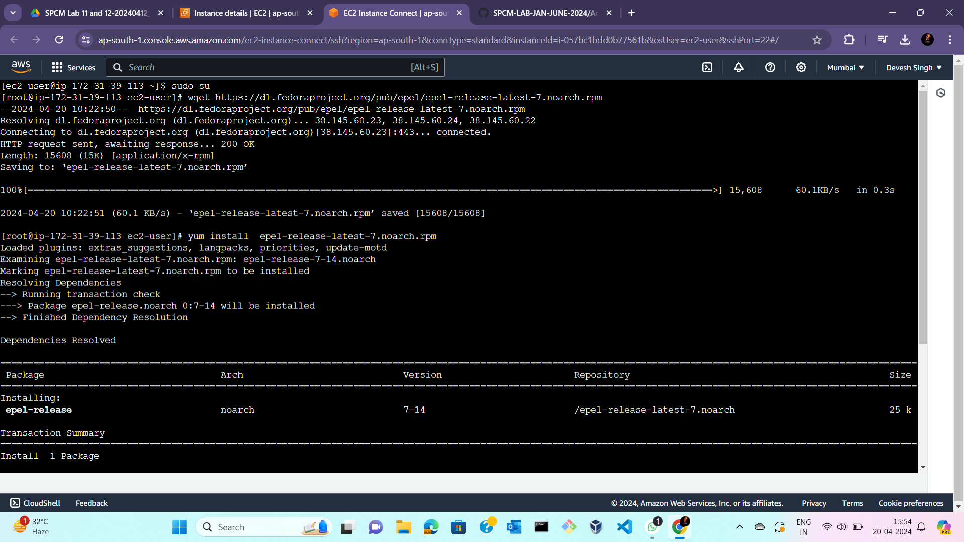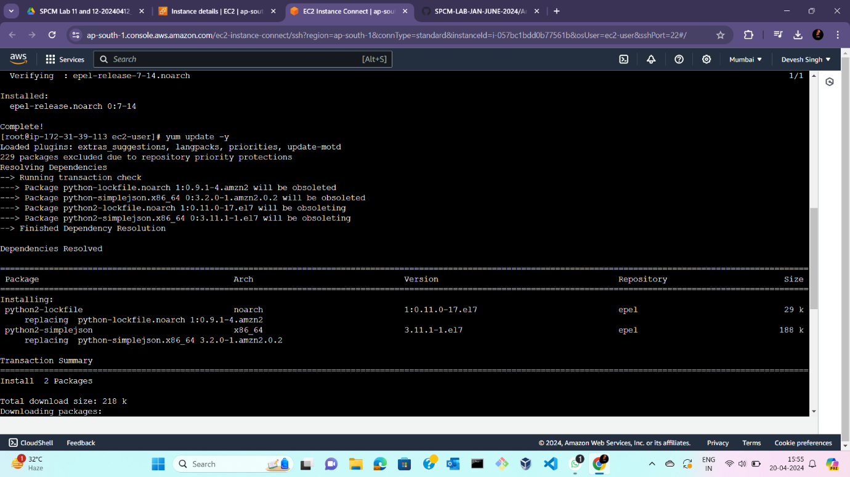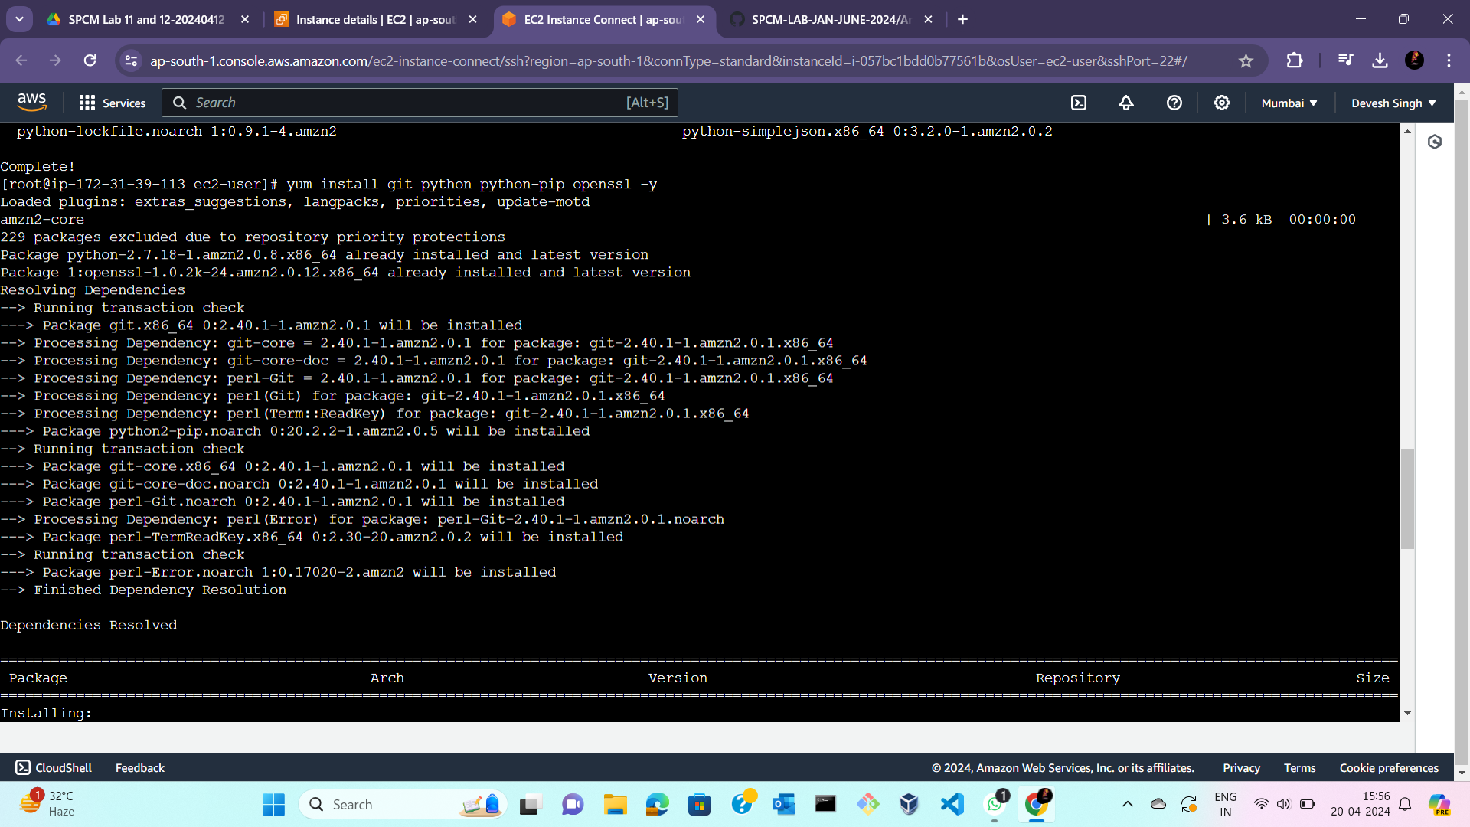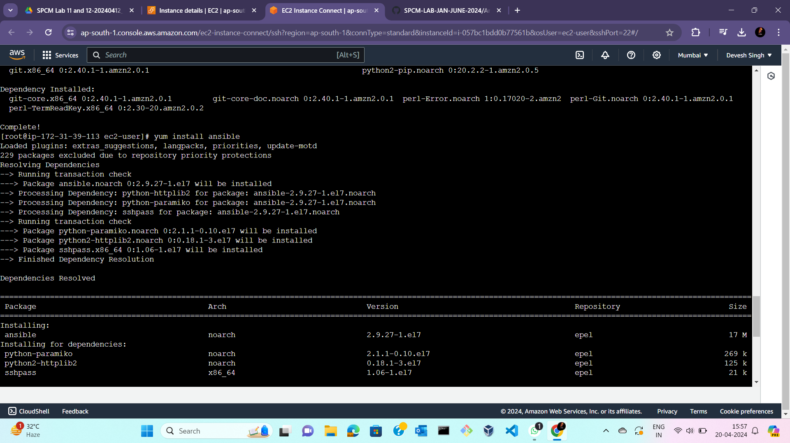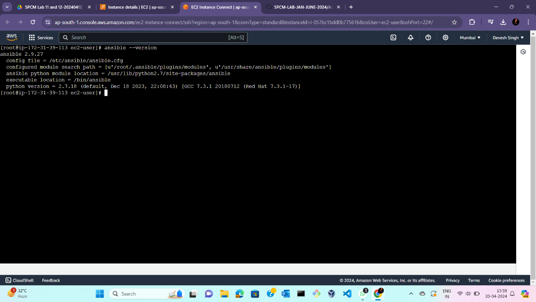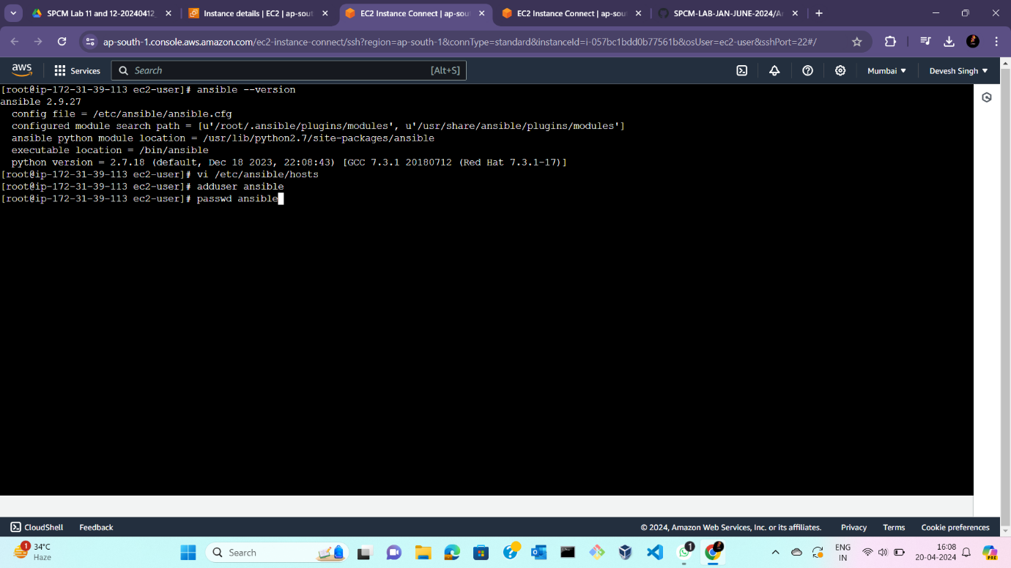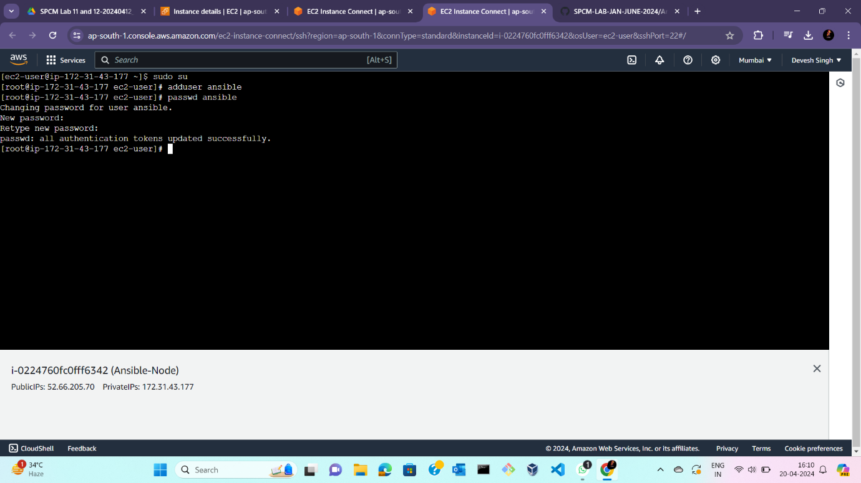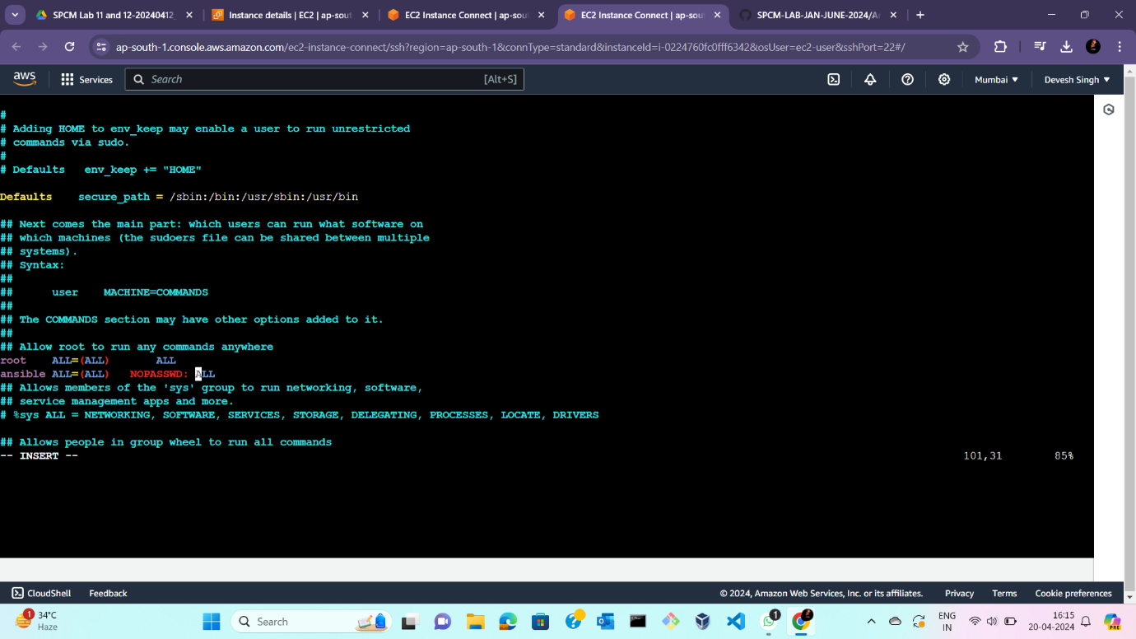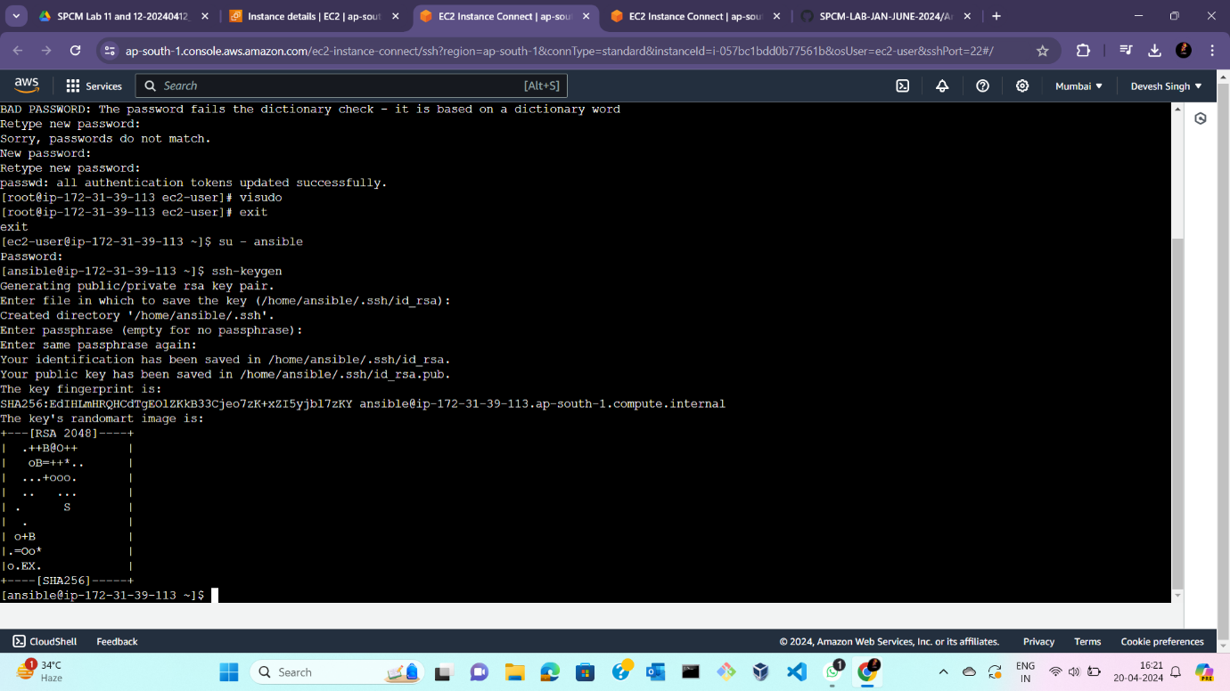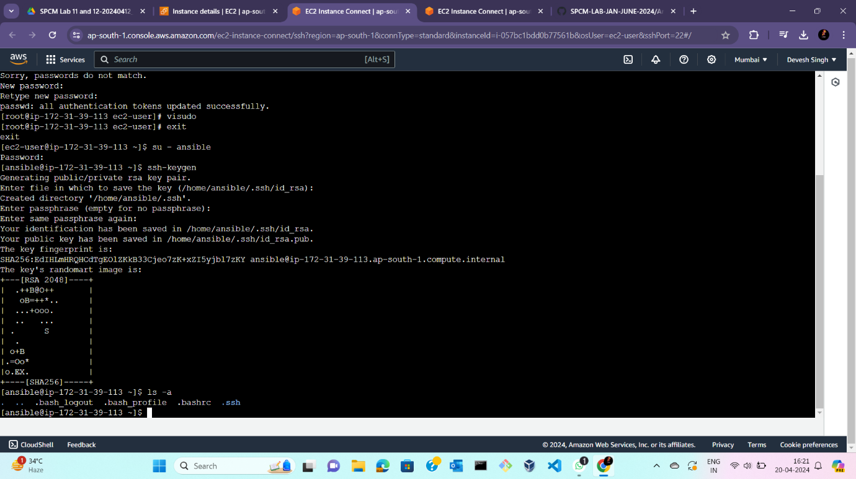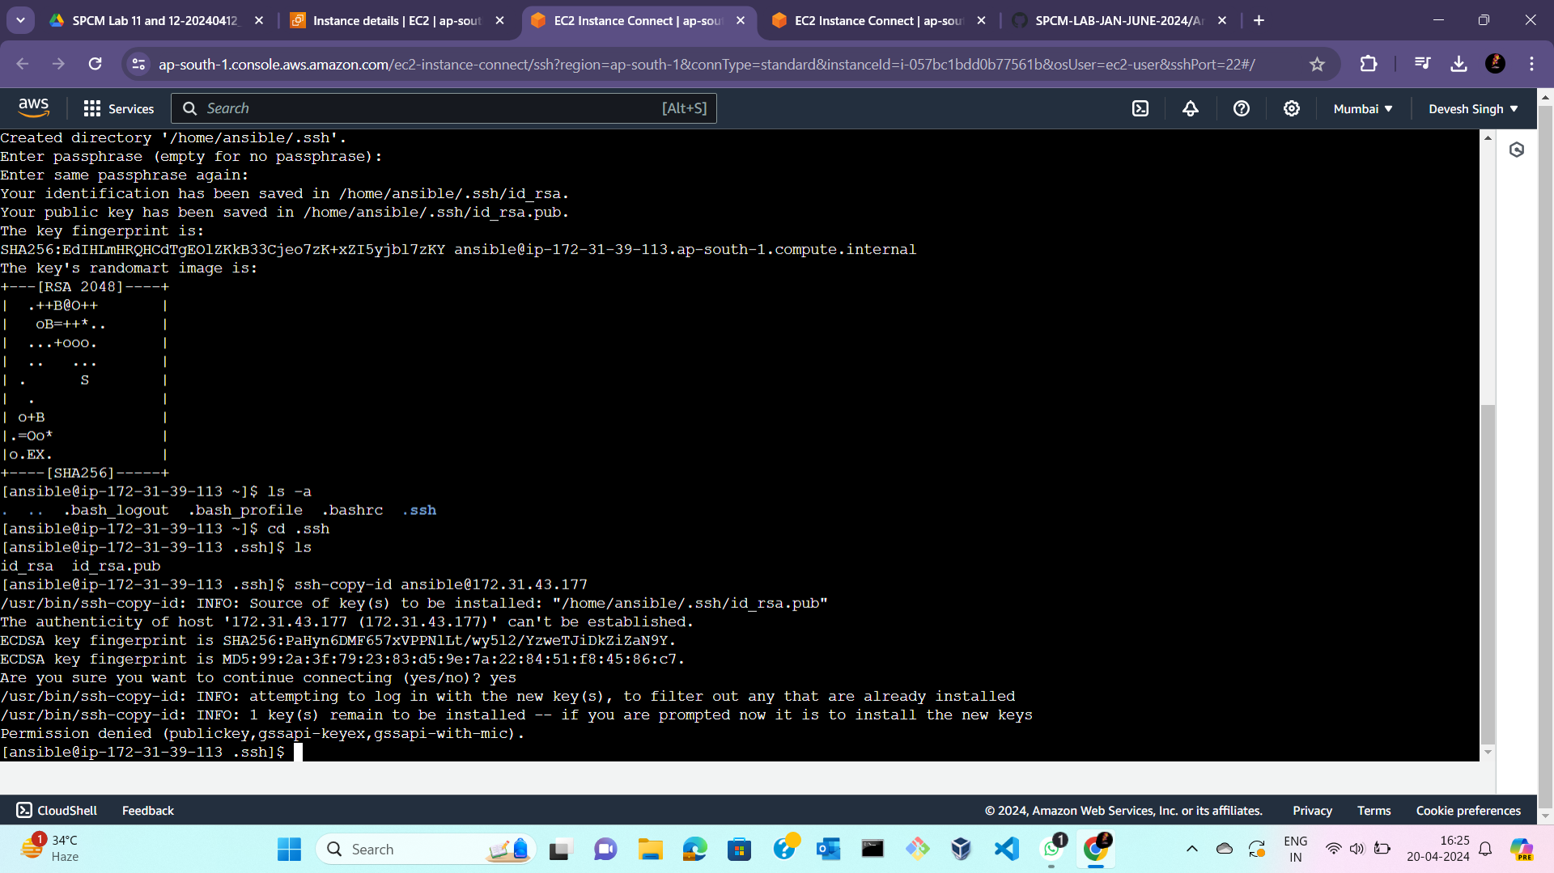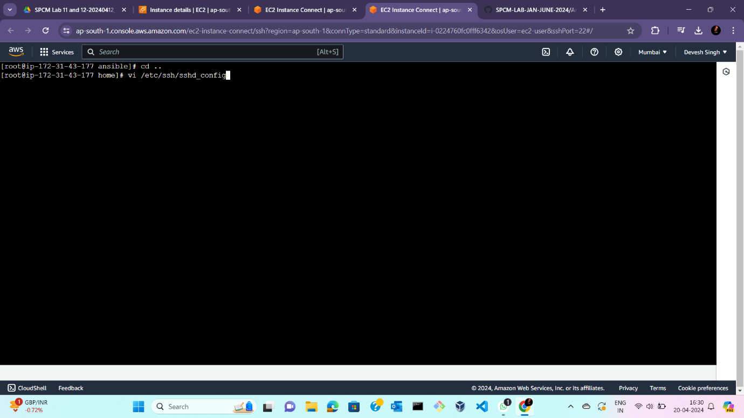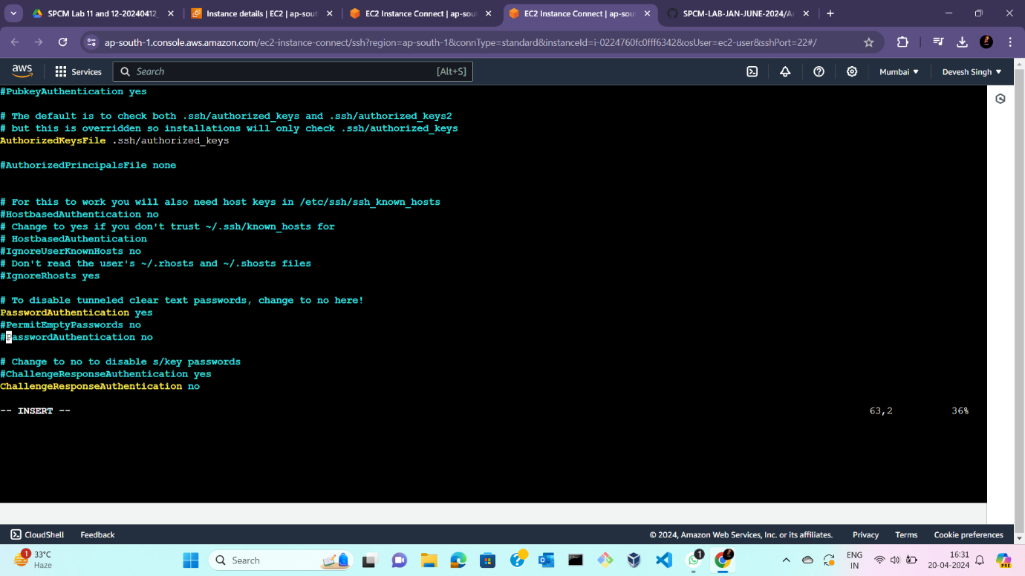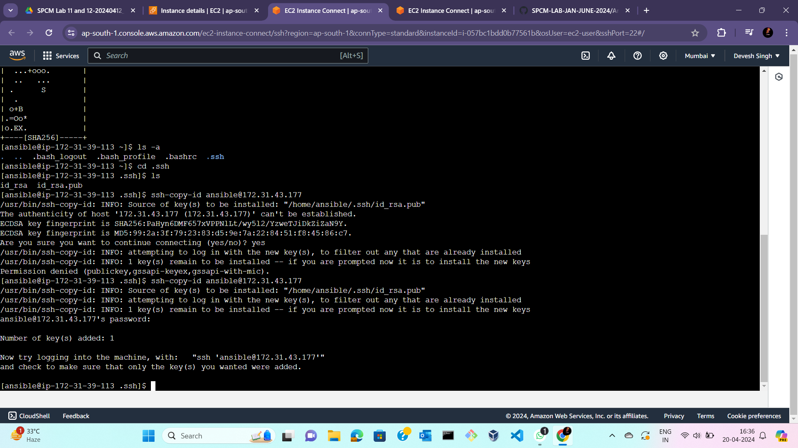  
  
  
**\*\*\*\* END OF EXPERIMENT -11 \*\*\*\*\***